SKDC Briefing: Council Tax & Non-Domestic Rates Collection 2023/24
This briefing summarises South Kesteven District Council’s (SKDC) performance in the collection of council tax and non-domestic rates for the period 2019/20 to 2023/24. The source is the annual statistics on the topic produced by the Department for Levelling Up, Housing & Communities (DLUHC).
Council Tax
In 2023/24, SKDC achieved a collection rate of 98.36%. This is a -0.11% decrease on 2022/23. The overall trend since 2019/20 has been a very slight decline of -0.08%. Unlike the other comparators, collection does not seem to have been significantly impacted by the pandemic. SKDC’s best performance in the examined period was 98.64% in 2021/22. (Figure 1). The estimated collectable net debit of £99.6 million (2023/24) is the highest in Lincolnshire and the 173rd largest in England.
SKDC had the second highest collection rate in Lincolnshire. The Lincolnshire mean collection rate in 2023/24 was 96.21%. (Table 1). SKDC also ranked second amongst its CIPFA nearest neighbours. The CIPFA peer mean collection rate was 97.48%. (Table 2). Regionally SKDC had the fifth highest rate in the East Midlands. The East Midlands mean was 96.63%. Nationally, SKDC ranked twenty-firth, amongst the top 10% of English authorities. The mean collection rate in England was 95.94%.
Table 1: Council Tax Collection – Lincolnshire Neighbours 2023/24
Decile Key: Decile 10 – in the top 10% of English local authorities, Decile 1 – in the bottom 10% of English local authorities, Deciles 6+ in the top half of English local authorities.
Lincs Ranking | Authority | Value | National Decile Placing | National Ranking
1 | North Kesteven | 98.48% | Top (10) | 20
2 | South Kesteven | 98.37% | Top (10) | 25
3 | West Lindsey | 97.73% | 8 | 74
4 | South Holland | 96.19% | 4 | 191
5 | East Lindsey | 95.37% | 4 | 211
6 | Lincoln | 94.04% | 2 | 246
7 | Boston | 93.37% | Bottom (1) | 268

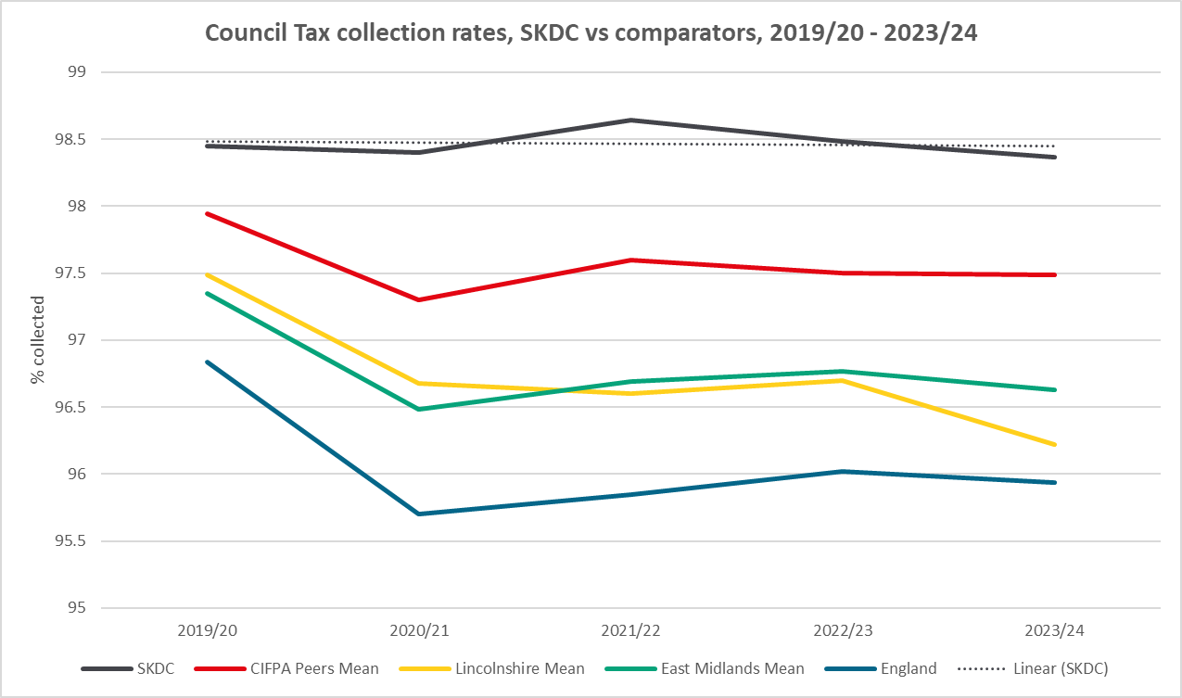
Figure 1 - Council Tax Collection Rates, SKDC vs Comparators 2019/20 - 2023/24, Source: Council Tax statistics, DLUHC
Table 2: Council Tax Collection – CIPFA Peers 2023/24
Decile Key: Decile 10 – in the top 10% of English local authorities, Decile 1 – in the bottom 10% of English local authorities, Deciles 6+ in the top half of English local authorities.
CIPFA Peers Ranking | Authority | Value | National Decile Placing | National Ranking
1 | Amber Valley | 98.57 | Top (10) | 14
2 | South Kesteven | 98.37 | Top (10) | 25
3 | High Peak | 98.28 | 9 | 36
4 | Stroud | 97.66 | 8 | 79
5 | Stafford | 97.63 | 8 | 80
6 | Gedling | 97.63 | 8 | 81
7 | Broxtowe | 97.63 | 8 | 82
8 | Braintree | 97.59 | 8 | 85
9 | Hinckley & Bosworth | 97.52 | 7 | 95
10 | Breckland | 97.25 | 7 | 113
11 | Newark & Sherwood | 97.21 | 6 | 118
12 | Chorley | 96.90 | 6 | 142
13 | Bassetlaw | 95.50 | 3 | 207

Non-Domestic Rates
In 2023/24, SKDC achieved a collection rate of 99.05%. This is a 1.12% increase on 2022/23. The 2023/24 figure is -0.11% lower than 2019/20. The overall trend is recovery from the pandemic. (Figure 2). The estimated collectable net debit of £40.1 million (2023/24) is the highest in Lincolnshire and the 192nd largest in England.
SKDC had the highest collection rate in Lincolnshire. The Lincolnshire mean collection rate in 2023/24 was 96.77%. (Table 2). SKDC also ranked first amongst its CIPFA nearest neighbours. The CIPFA peer mean collection rate was 97.60%. (Table 4). Regionally SKDC had the second highest rate in the East Midlands. The East Midlands mean was 97.15%. Nationally, SKDC ranked thirty-firth, amongst the top 20% of English authorities. The mean collection rate in England was 97.23%.
Table 3: Non-Domestic Rates Collection – Lincolnshire Neighbours 2023/24
Decile Key: Decile 10 – in the top 10% of English local authorities, Decile 1 – in the bottom 10% of English local authorities, Deciles 6+ in the top half of English local authorities.
Lincs Ranking | Authority | Value | National Decile Placing | National Ranking
1 | South Kesteven | 99.05 | 9 | 35
2 | North Kesteven | 99.03 | 9 | 39
3 | West Lindsey | 98.33 | 7 | 95
4 | Lincoln | 98.32 | 7 | 96
5 | South Holland | 95.16 | 2 | 266
6 | East Lindsey | 93.77 | 1 | 286
7 | Boston | 93.75 | 1 | 287

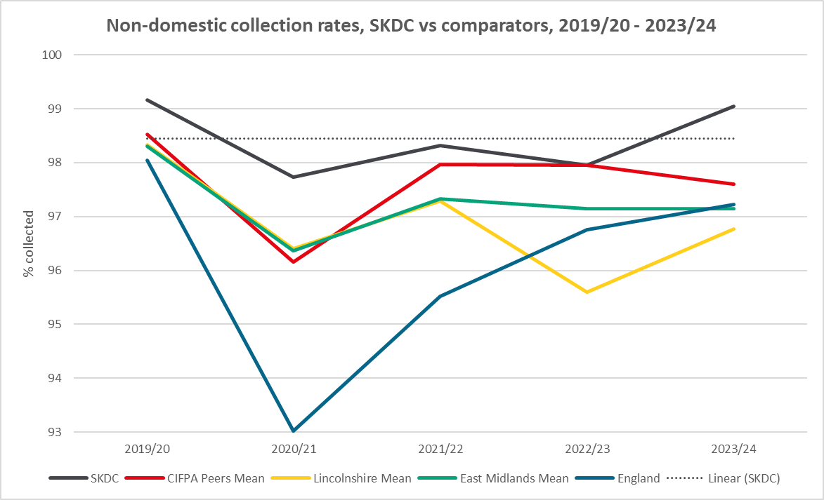
Figure 2 - Non-Domestic Collection Rates, SKDC vs Comparators 2019/20 - 2023/24, Source: Council Tax statistics, DLUHC

Table 4: Non-Domestic Rates Collection – CIPFA Peers 2023/24
Decile Key: Decile 10 – in the top 10% of English local authorities, Decile 1 – in the bottom 10% of English local authorities, Deciles 6+ in the top half of English local authorities.
CIPFA Peers Ranking | Authority | Value | National Decile Placing | National Ranking
1 | South Kesteven | 99.05 | 9 | 35
2 | Amber Valley | 98.88 | 9 | 48
3 | High Peak | 98.68 | 8 | 65
4 | Hinckley & Bosworth | 98.45 | 8 | 88
5 | Braintree | 98.12 | 7 | 105
6 | Chorley | 97.98 | 6 | 119
7 | Gedling | 97.88 | 6 | 125
8 | Stafford | 97.86 | 6 | 127
9 | Newark & Sherwood | 97.8 | 6 | 133
10 | Broxtowe | 97.71 | 6 | 142
11 | Breckland | 97.42 | 5 | 166
12 | Stroud | 96.42 | 3 | 232
13 | Bassetlaw | 92.25 | Bottom (1) | 293

Council Tax statistics - GOV.UK (www.gov.uk), specifically Table 9: Quarterly return of Council tax and non-domestic rates QRC4, for each examined year.

